**TEAM CONTRACT**

1. **Information**

| ***Student ID*** | ***Name*** | ***Role*** | ***Signature*** |
| --- | --- | --- | --- |
| 23127099 | Nguyễn Ngọc Hưng Phát | Developer |  |
| 23127118 | Lê Nguyên Thảo | Designer |  |
| 23127269 | Đỗ Đăng Nhật Tiến | Business Analyst |  |
| 23127447 | Nguyễn Thanh Owen | Developer, Leader |  |
| 23127464 | Trần Minh Quang | Developer, Tester |  |

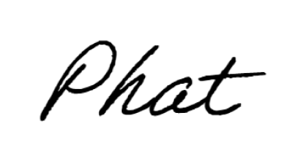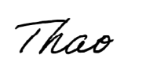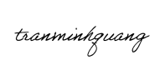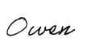

1. **Terms and Conditions**
   1. **Communication Plan:**

* Communication tools and the frequency of meetings:
* **Discord**: Sundays at 7:00 PM
* **Library**: Wednesdays at 10:00 AM
* Protocols for decision-making and conflict resolution: The leader will make the final decision based on majority opinion and feasibility.
* Expectations for response times to messages and deliverables: Team members are expected to respond within 24 hours to messages and deliverables.
  1. **Work Schedule and Deadlines:**
* Each member has their own individual deadlines.
* If a deadline cannot be met:
* Notify at least 24 hours in advance.
* Provide a reason.
* Report the work completed so far.
* Extension duration depends on task complexity.
  1. **Code and Documentation Standards:**
* Coding conventions and tools: Use GitHub for code management.
* Expectations for code reviews and testing procedures: Prioritize code readability and maintainability.
* Project documentation: Include clear and updated documentation throughout the project.
  1. **Accountability and Performance:**
* Criteria for measuring contribution and quality of work: Based on task completion level, evaluated by the team leader.
* Handling underperformance or lack of participation:
* 1st offense: Warning.
* 2nd offense: Deduct 50% from Weekly Task contribution.
* 3rd offense: Deduct 50% from PA contribution.
* 4th offense: Deduct 75% from PA contribution.
* 5th offense: Deduct 100% from PA contribution.
* Consequences for not adhering to the team contract: Deduct 100% from Project contribution.
  1. **Decision-Making Process:**
* Define how decisions will be made: majority vote.
* Leader has the final say in case of disagreements.
  1. **Conflict Resolution:**
* If a conflict arises:
* All parties present their opinions.  
  The leader makes the decision.
* If the rejected party disagrees with the leader’s decision, a vote will be conducted.
* If disagreement persists after the vote, the individual is considered in violation of the contract.
  1. **Review and Update Contract:**
* Terms will be updated if new issues arise that are not covered in the current contract.
* A team vote will be held to update the contract accordingly.